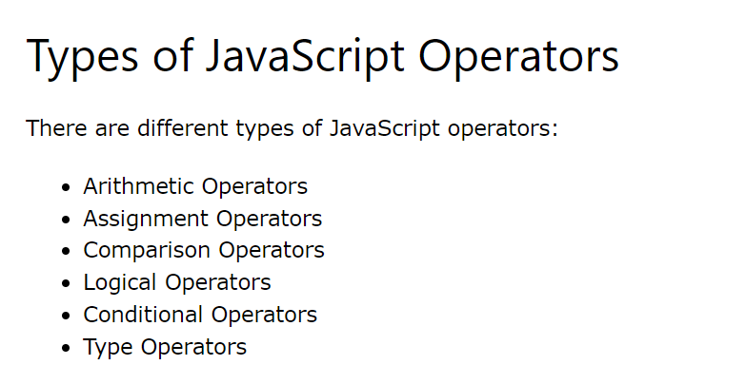

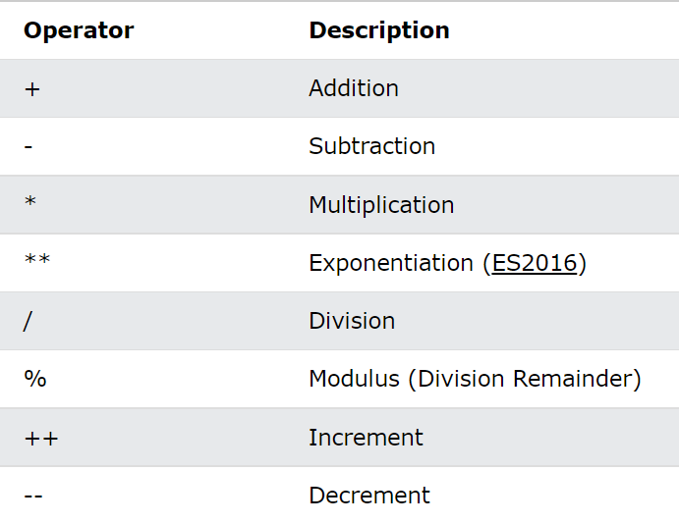**Arithmetic Operators**

**Assignment Operators**

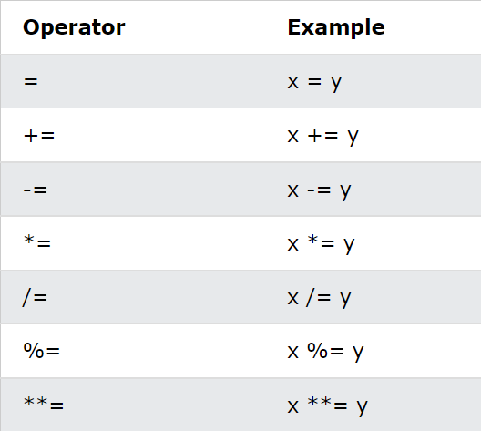

**String Operators**

+ operator to concatenate strings

**Comparison Operators**

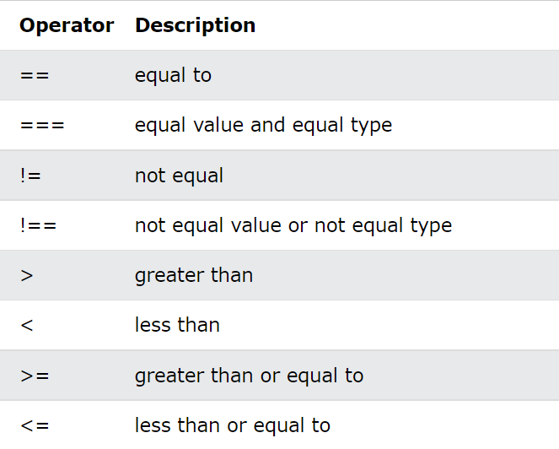

**Logical Operators**

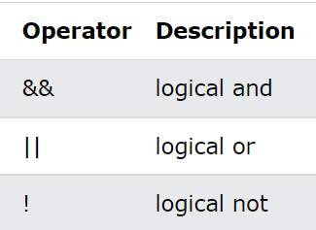

**Type Operators**

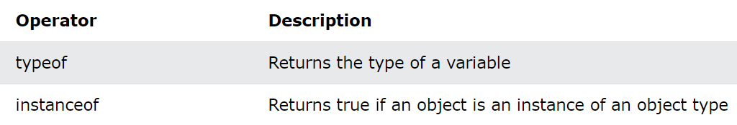

Ternary Operators

?: = (condition)?true:false;